Week 8 Progress Report – AWS Cloud Learning
Week: 8
Course: AWS Certified Generative AI Developer – Professional
Focus
• AWS Managed AI Services
• Amazon Transcribe and speech-to-text processing
• Amazon Polly and text-to-speech conversion
• Amazon Rekognition and image/video analysis
• Amazon Lex and conversational AI
• Amazon Personalize and personalized recommendations
• Amazon Textract and document text extraction
• Amazon Quick
• AWS hardware for AI
• Hands-on practice with AWS AI services
Resources Used
• Udemy – AWS Certified Machine Learning Engineer – Associate
• AWS AI and machine learning course lessons
• AWS Management Console learning materials
• Hands-on demonstrations and practice activities
• AWS Managed AI Services lessons
Hands-on Labs / Course Activities
• Completed Amazon Transcribe – Hands On.
• Completed Amazon Polly – Hands On.
• Completed Amazon Rekognition – Hands On.
• Completed Amazon Lex – Hands On.
• Completed Amazon Textract – Hands On.
• Reviewed Amazon Personalize.
• Studied Amazon Quick and AWS hardware for AI.
• Completed the Quiz 3: AWS Managed AI Services, as shown in the course screenshot.
Topics Covered from Udemy
Speech and Audio AI
• Amazon Transcribe – Hands On
• Amazon Polly
• Amazon Polly – Hands On
Image and Video AI
• Amazon Rekognition
• Amazon Rekognition – Hands On
Conversational AI
• Amazon Lex
• Amazon Lex – Hands On
Personalization and Document Processing
• Amazon Personalize
• Amazon Textract
• Amazon Textract – Hands On
Additional AI Topics
• Amazon Quick
• Amazon's Hardware for AI
• Amazon's Hardware for AI – Hands On
• Quiz 3: AWS Managed AI Services
Learning Outcomes
• Learned about Amazon Transcribe and its use in converting speech into text.
• Understood how Amazon Polly converts written text into speech.
• Learned about Amazon Rekognition and its image and video analysis capabilities.
• Studied Amazon Lex and its role in building conversational interfaces and chatbots.
• Learned how Amazon Personalize supports personalized recommendations.
• Studied Amazon Textract and its ability to extract text and structured information from documents.
• Gained introductory knowledge of Amazon Quick.
• Reviewed AWS hardware topics related to AI workloads.
• Improved understanding of AWS Managed AI Services through course lessons and hands-on activities.
Evidence Collected
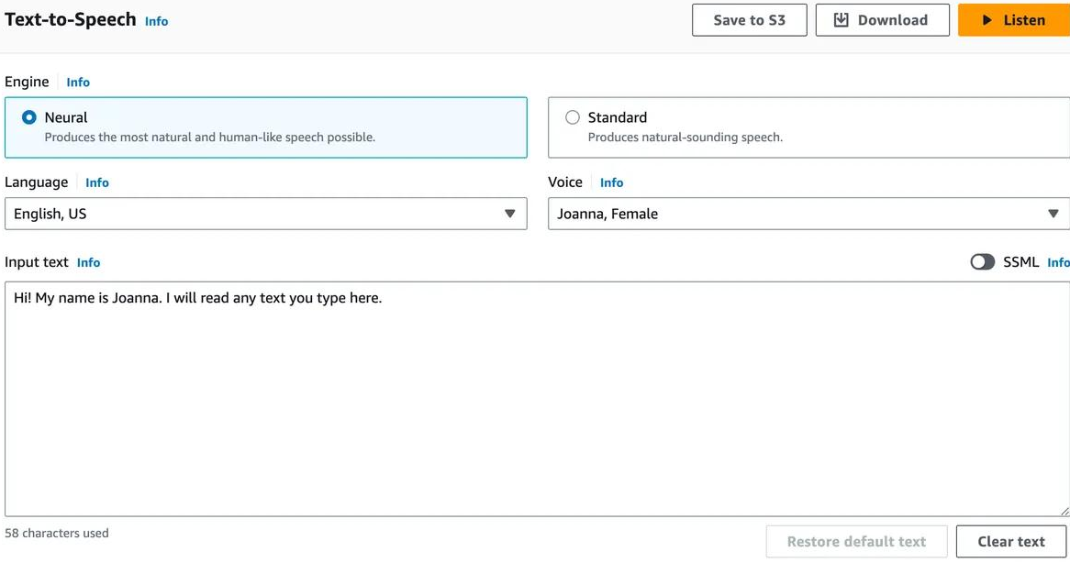

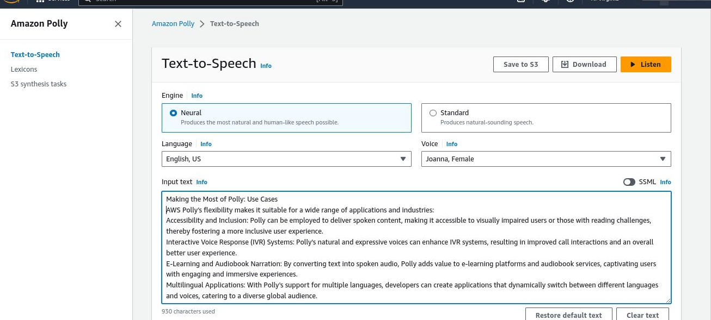

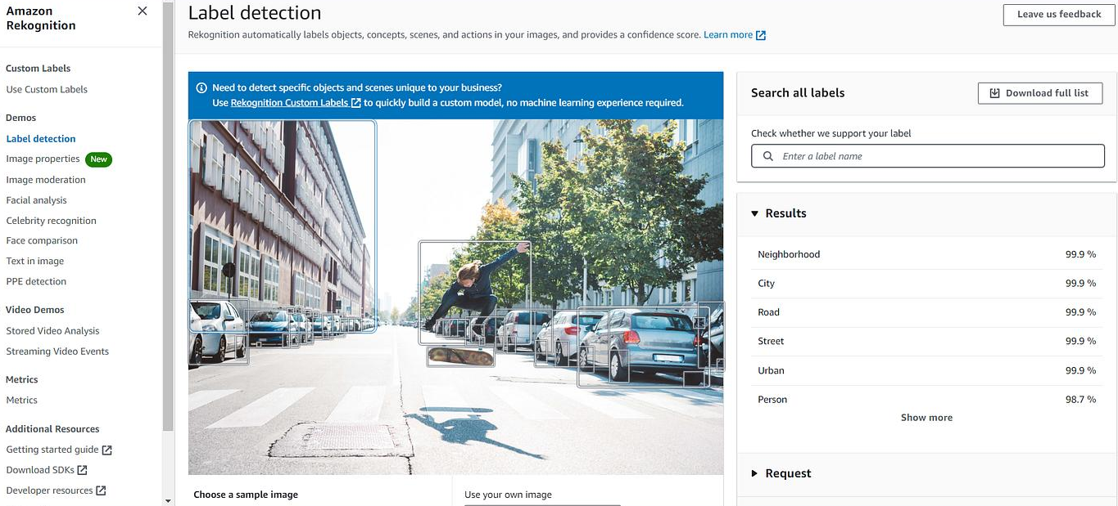
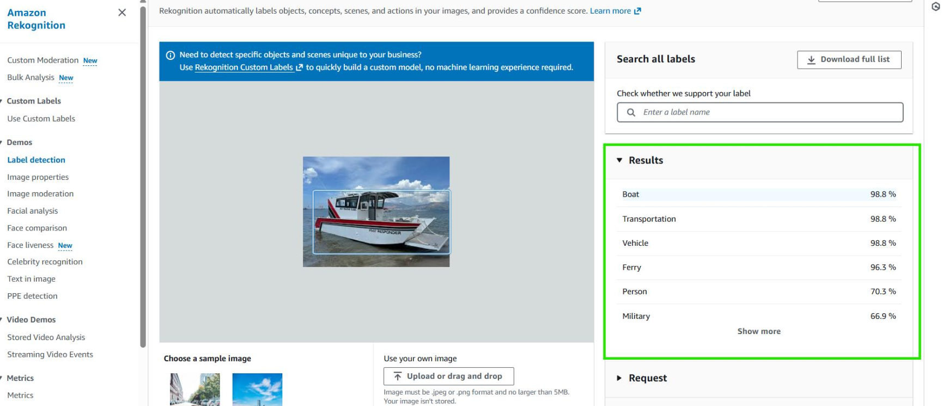

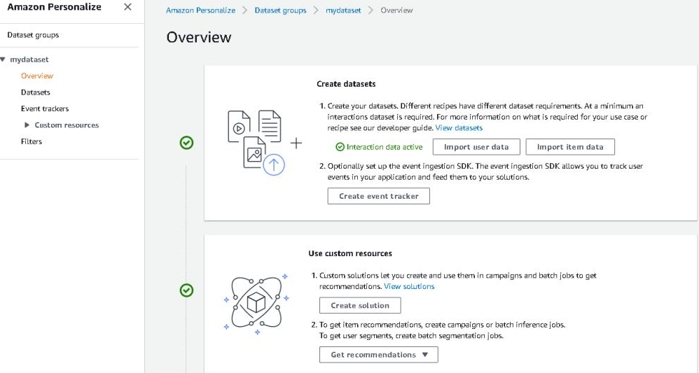

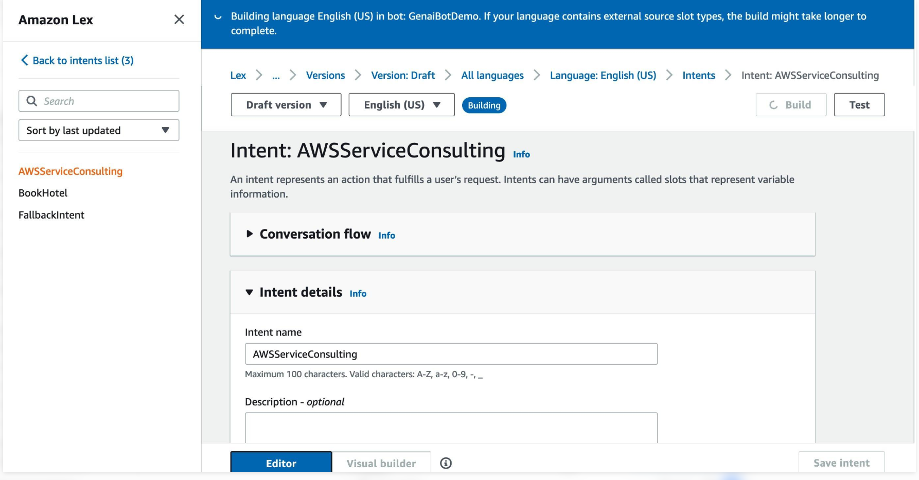

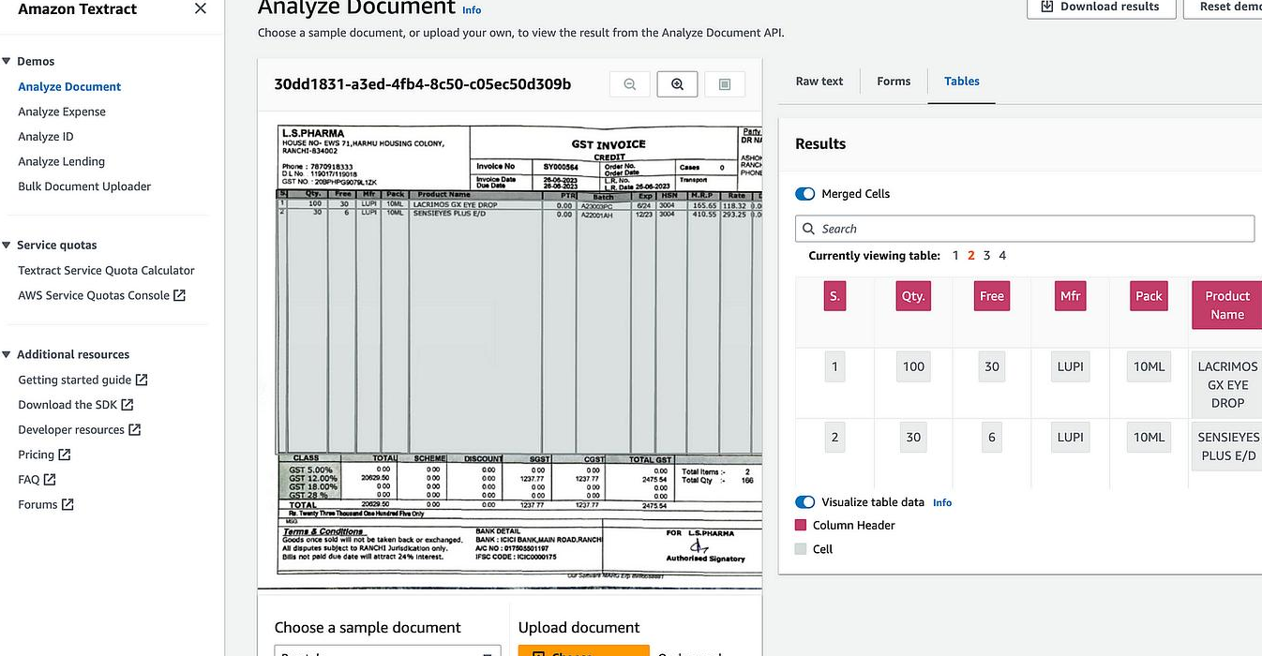
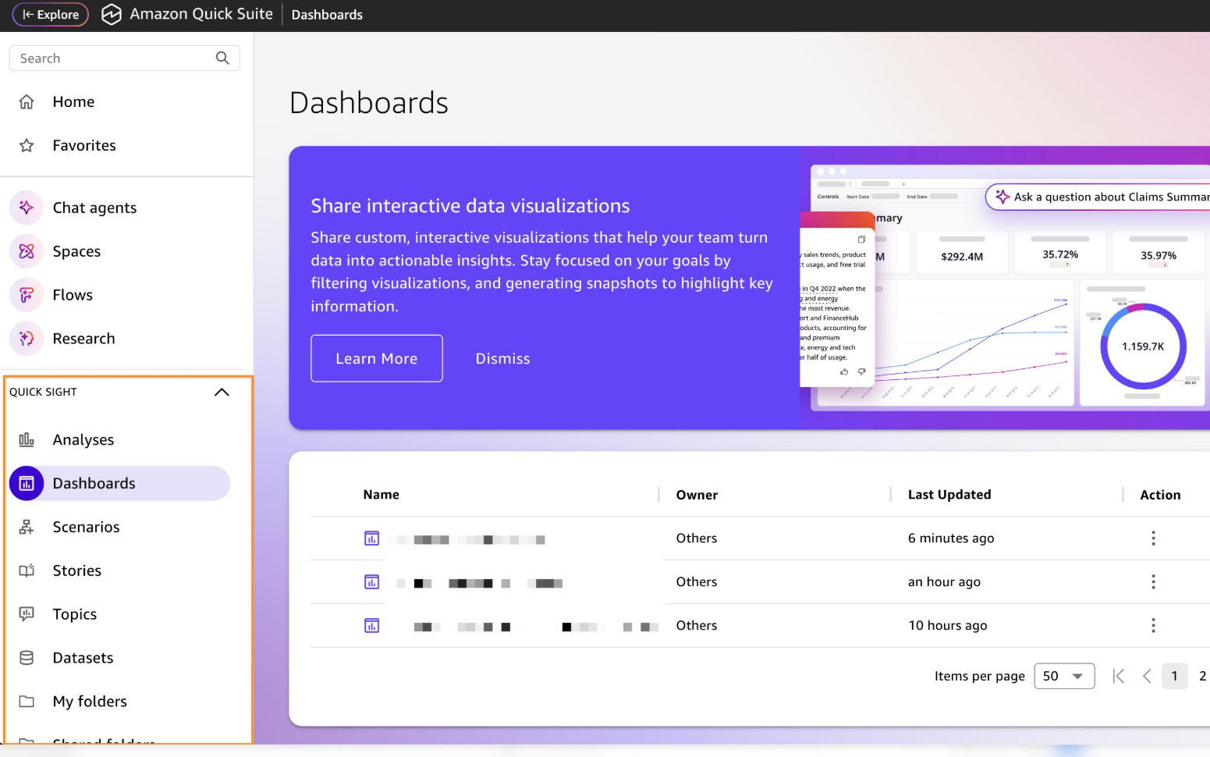

AWS Managed AI Services – Practical Learning
Tasks Performed
• Studied Amazon Transcribe and its speech-to-text functionality.
• Reviewed the Amazon Polly hands-on lesson.
• Learned about image and video analysis with Amazon Rekognition.
• Studied conversational AI concepts using Amazon Lex.
• Reviewed Amazon Personalize and recommendation systems.
• Learned about extracting information from documents using Amazon Textract.
• Reviewed Amazon Quick and AI-related hardware topics.
• Completed the course lessons and quiz shown in the Udemy screenshot.
Practical Applications of AWS AI Services
• Amazon Transcribe: Converting recorded speech into text.
• Amazon Polly: Generating spoken audio from text.
• Amazon Rekognition: Analyzing images and videos.
• Amazon Lex: Building conversational interfaces and chatbots.
• Amazon Personalize: Creating personalized recommendations.
• Amazon Textract: Extracting text and information from scanned documents and forms.
Issues Faced & Fixes
• Understanding the differences between AWS AI services – reviewed the individual service lessons and their applications.
• Understanding speech and audio processing – studied the Transcribe and Polly lessons.
• Understanding document extraction and image analysis – reviewed the Textract and Rekognition lessons.
• Understanding conversational AI and recommendation systems – reviewed Amazon Lex and Amazon Personalize.
Next Week Plan
• Continue with the remaining AWS Certified Machine Learning Engineer – Associate course topics.
• Complete upcoming lessons and hands-on practice activities.
• Review AWS AI and machine learning services.
• Practice applying AWS services to practical use cases.
• Continue preparing for the AWS Certified Machine Learning Engineer – Associate certification.

